Explore the World:  - The Apollo 11 Mission lifted off in the United States of America. Can you find the USA on an atlas? Can you make a flag of the USA? What does it look like?  - The International Space Station orbits Earth 16 times a day. Can you find out how many miles once around the Earth is? How long would it take to drive around the Earth, or fly in an aeroplane or even in a hot air balloon? | Power Project  Spring Term – Potters Cycle B  Power Projects are an important way of extending and embedding pupils’ learning and vocabulary.  They also prepare children for future homework expectations.  The pupils will share their learning on our ‘school museum day’ on  Friday 20th March  No more than three pieces of work are expected.  If you have any questions, please see us or email:  Mrs.Woodley  Woodley@crockerton.wilts.sch.uk | Explore the Past:  - Can you find out who was the first person in space? What was their name and which country did they come from? When did they go into Space? What did they do when they went into Space?  - Did you know that some animals have visited Space? Can you find out what kind of animal was first and which country did it come from? Can you draw or paint a picture of the animal? The animal had a name; what was it?
Be Creative:  - Neil Armstrong was the first human to walk on the moon in 1969. Imagine you are Neil Armstrong and you have just arrived on the moon. You are writing in your space log about the journey to the moon (remember it took 4 days!) and what you can see now that you are there. Write ‘The Day I walked on the Moon’ as your space log.  - Find reclaimed materials at home to make collage planets. Create a flat circle shape and cover it with materials like bubble wrap, packing materials, cellophane, tin foil to create the different surfaces of the planets. A useful link to planet facts is here: https://www.turito.com/learn/earth-and-science-space/surface-feature-of-the-planets | Values – Respect and Rules and Values  - We have been focussing on our school value Respect. Talk to your child about what this means and how they show respect.  - Play a board game at home. It could be Snakes and Ladders, Jenga or any game that involves taking turns. Think about how you are playing this game respectfully (being patient, taking turns, listening and coping with not winning the game!)  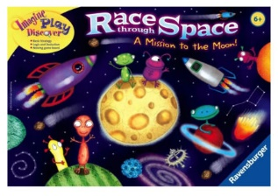 | STEM Challenge  (Science, technology, engineering and mathematics)  - Rockets and Spacecraft are made from materials that are light but incredibly strong. They have to withstand very high temperatures.  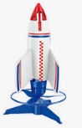  - Can you find out what materials are used to build Spacecraft and explain why those materials are used? Build your own model rocket using materials that look like the real thing. Think about the 3d shapes that you can find at home that would make fuel containers and nose cones.
