Explore the World:  - Design a leaflet to encourage tourists to visit Egypt. Which landmarks and important places should they visit and why?  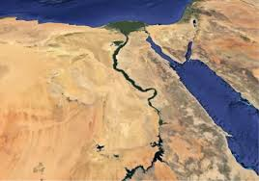  - The River Nile was very important to the Ancient Egyptians; it is also the longest river in the world. Choose five rivers in the world and order them according to their length. You could present your findings in a bar graph, as a Power Point on Google classrooms, or as a fact file. | Power Project  Egypt: discovery, wonder and curiosity  Welcome to this term’s power project.  Power Projects are an important, exciting way of extending and embedding pupils’ learning and vocabulary, whilst also encouraging children to present and take pride in their learning.  The pupils will share their learning on our ‘school museum day’ on  Friday 20th March – just a reminder that this is the day we expect to see projects in school, please.  No more than three pieces of work are expected. We can’t wait to see them and share together!  If you have any questions, please see me or email:  sophie.woodley@crockerton.wilts.sch.uk | Explore the Past:  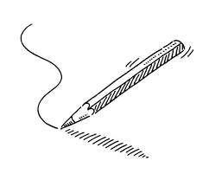  - Draw two images of Egypt. One from Ancient Egypt, and one of modern-day Egypt. What are the similarities and differences? Consider: clothing, housing, jobs, transport. Make sure you label your drawings.  - Explore and research Egyptian Gods and Goddesses. Create an Egyptian god fact file. You could design and make some Egyptian gods top trump cards.
Be Creative:  - Imagine you were there when Howard Carter discovered Tutankhamen’s tomb. Perhaps you are Howard Carter himself! Write a diary entry, or newspaper report about the event. Use these as prompts: Who? What? When? Where? How?  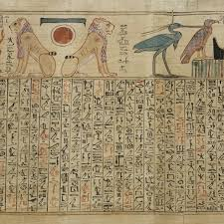  - Have a go at making your own papyrus-style paper and use it as the basis for some Ancient-Egyptian themed artwork or writing. You could draw an Ancient Egyptian god or write a message in your own secretly-coded hieroglyphs (don’t forget to include a key!)  https://primarytopicshop.co.uk/making-papyrus-paper/ | Values – Respect and Rules and Values  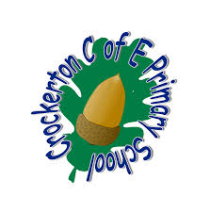  - In worship, we have been thinking about ways we can show gratefulness and in class, we have been talking about team work and celebrating differences. Choose on theme and write a short story, create a comic strip, or film a short video about a scenario (real or imagined) which features a character being grateful, respectful to others or showing team work.  - Our school rules are: ‘Be kind, be safe, be responsible and ready’. Choose one of these rules and create a poster (which we can display in school) to give other children advice to ensure they are being kind, safe or responsible in the classroom or at playtime. | 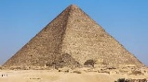  STEM Challenge  - The Ancient Egyptians were masters at mummification. Try mummifying a tomato! Take pictures each week and keep notes about the changes you see.  Full instructions can be found here: https://www.montalbo.durham.sch.uk/wp-content/uploads/sites/82/2020/05/Mummification-of-a-tomato.pdf  - The construction of the pyramids in Ancient Egypt represent an incredible feat of ancient engineering. Can you build your own structurally stable pyramid? You could use clay, lego, cardboard, recycled materials…use your imagination!  Write some instructions so your friends can recreate your pyramid.
