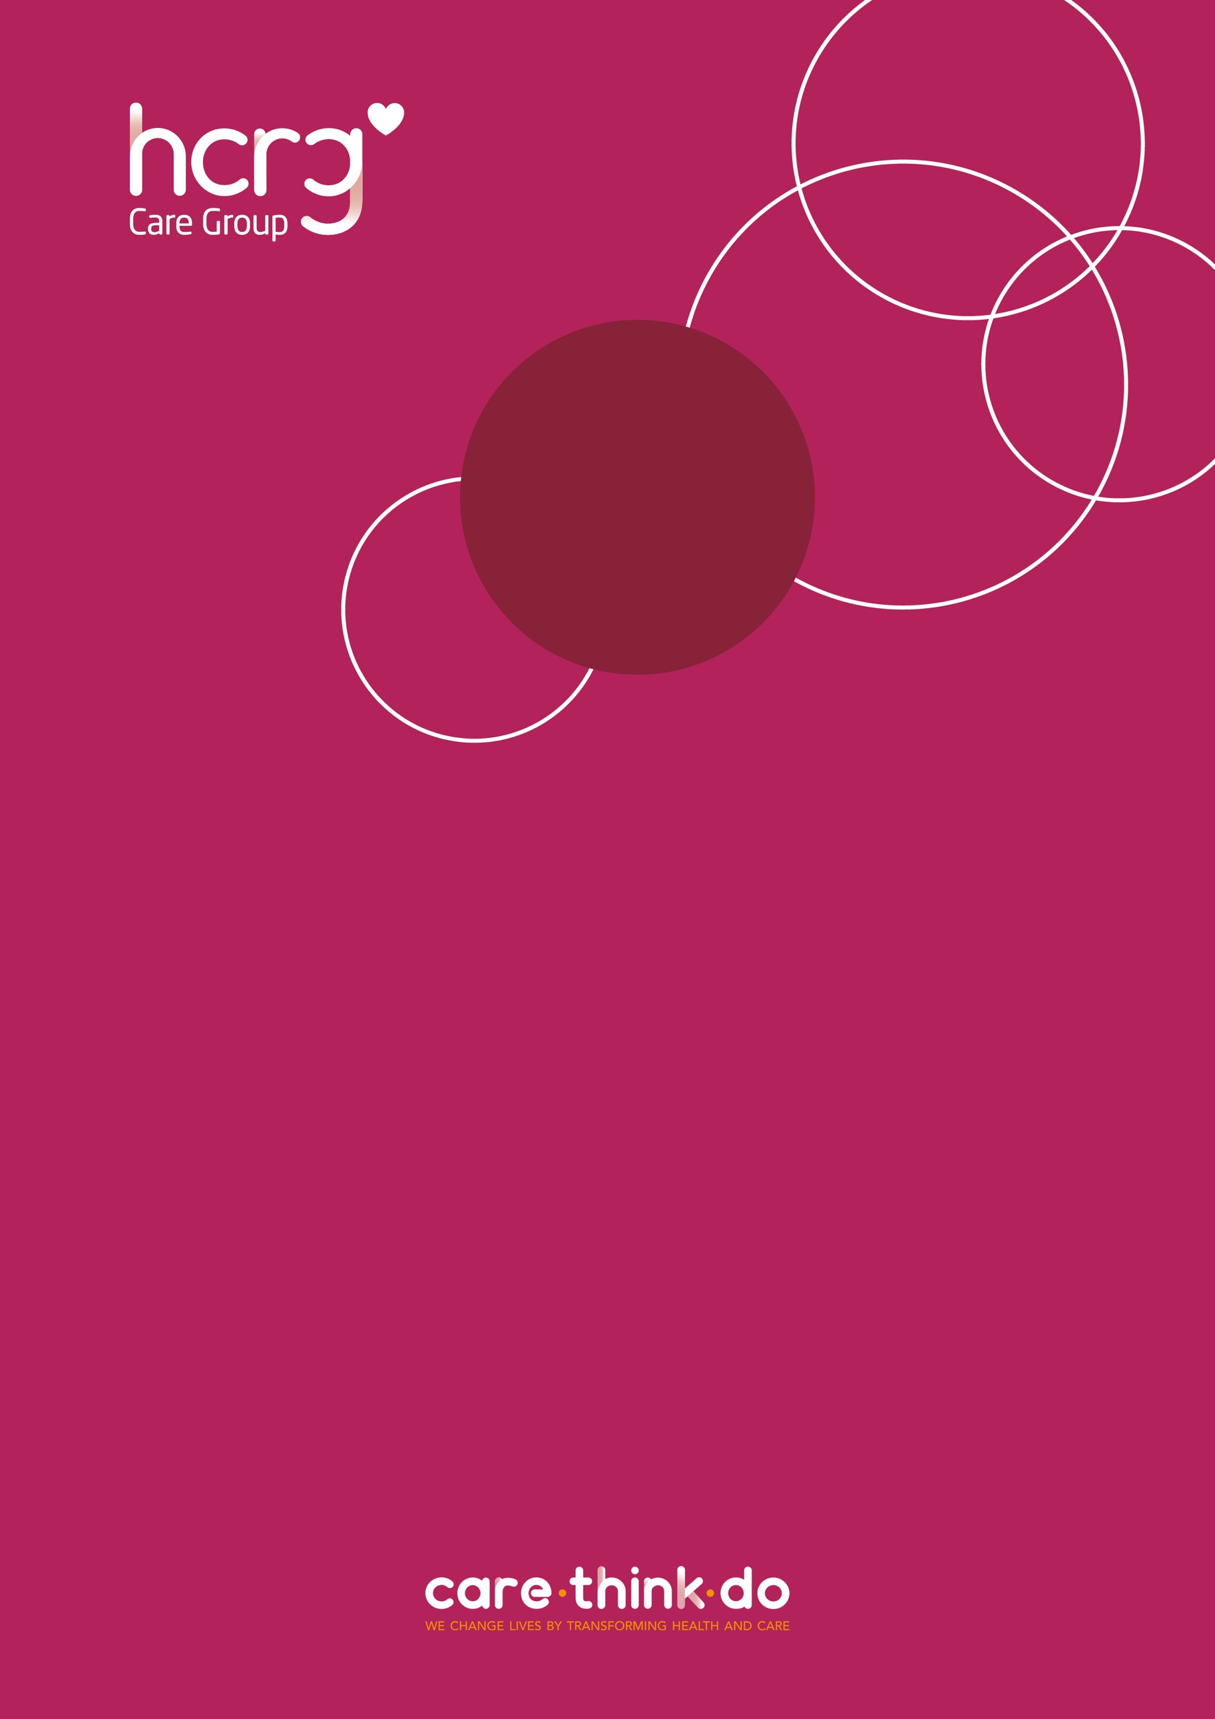

School Nursing Service
The School Nursing Service provides health-related, confidential support and advice to children and young people, their parents and carers, professionals, and community settings across Wiltshire.

- Mental and emotional health
- Physical health
- Healthy Lifestyles
- Sex & Relationships
- Drugs & Alcohol
- And much more…

You can find more information about the School Nursing Service at
wiltshirechildrensservices.co.uk/our-services/school-nursing/

How can I refer to the service?
Self-referrals can be made by young people (secondary school-aged) through attending School Nursing Service drop-ins or via Single Point of Access (details provided below).

Referrals can be made by parents/carers, as well as other agencies such as – education staff, GPs and social care (with parental/carer consent), by contacting Single Point of Access (SPA) –

0300 247 0090 (Monday – Friday 09:00 - 17:00)
vcl.wiltshirespa@nhs.net (email)
A ‘Request for support’ form can be accessed at
wiltshirechildrensservices.co.uk/our-services/spa/

