Puddings Dietary & Allergens – Weeks 1, 2, 3

Week 1 Dishes | 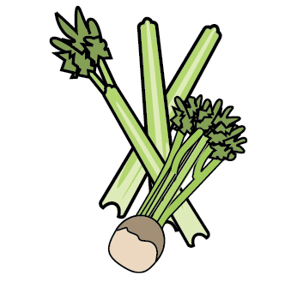 | 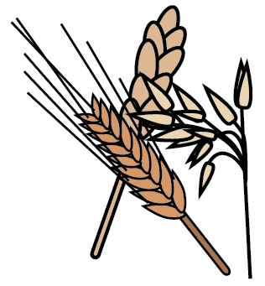 | 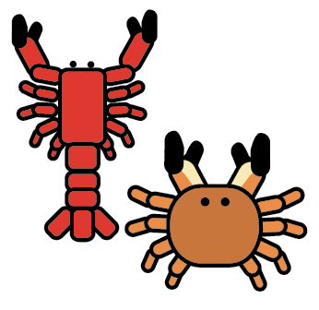 | 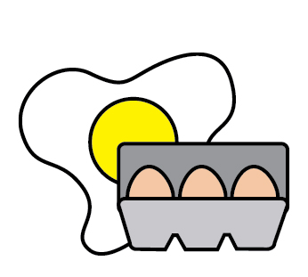 | 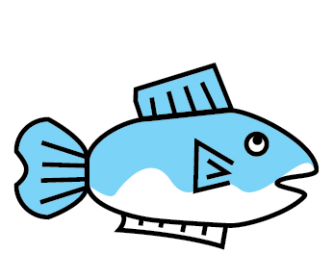 | 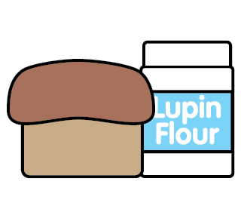 | 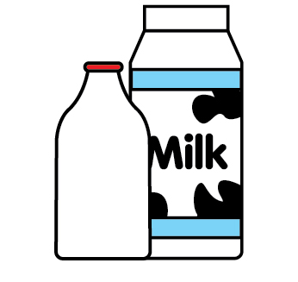 | 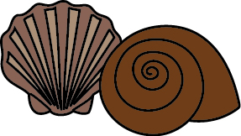 | 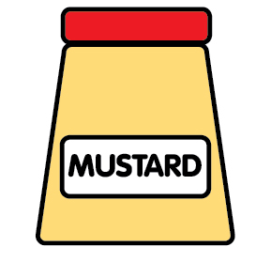 | 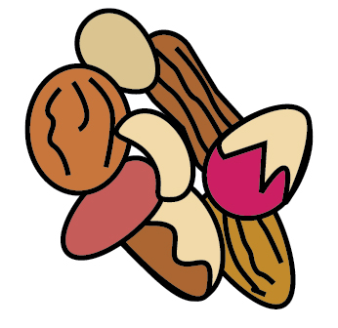 | 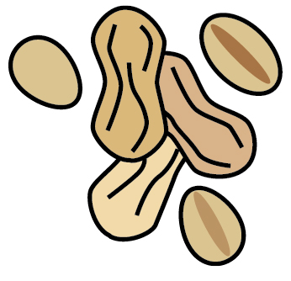 | 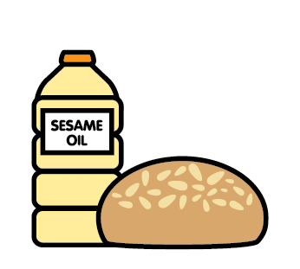 |  | 
 | Celery | Cereals containing gluten | Crustaceans | Eggs | Fish | Lupin | Milk | Mollusc | Mustard | Nuts | Peanuts | Sesame seeds | Soya | Sulphur Dioxide
VANILLA & CHERRY SPONGE |  | WHEAT |  | ✓
APRICOT & ORANGE CAKE |  | WHEAT |  | ✓
JELLY
SPICED CARROT CAKE, CREAM CHEESE FROSTING |  | WHEAT |  | ✓ |  |  | ✓
ICE - CREAM |  |  |  |  |  |  | ✓
CUSTARD |  |  |  |  |  |  | ✓

Week 2 Dishes
 | Celery | Cereals containing gluten | Crustaceans | Eggs | Fish | Lupin | Milk | Mollusc | Mustard | Nuts | Peanuts | Sesame seeds | Soya | Sulphur Dioxide
COOKIE |  | WHEAT |  | ✓ |  |  | ✓ |  |  | MAY CONTAIN |  |  | ✓
BANANA & TOFFEE CAKE |  | WHEAT |  | ✓ |  |  | ✓
JELLY
ACORN CAKE |  | WHEAT |  | ✓ |  |  | ✓
ICE - CREAM |  |  |  |  |  |  | ✓

Week 3 Dishes
 | Celery | Cereals containing gluten | Crustaceans | Eggs | Fish | Lupin | Milk | Mollusc | Mustard | Nuts | Peanuts | Sesame seeds | Soya | Sulphur Dioxide
VANILLA & RASPBERRY SPONGE |  | WHEAT |  | ✓
CHEESE & CRACKERS |  | WHEAT |  | ✓ |  |  | ✓ |  |  | TRACES
JELLY
JAM SPONGE |  | WHEAT |  | ✓
ICE CREAM |  |  |  |  |  |  | ✓
CUSTARD |  |  |  |  |  |  | ✓

