DISHES AND THEIR ALLERGEN CONTENT -MAIN COURSE PRIMARY WEEK 1

DISHES | 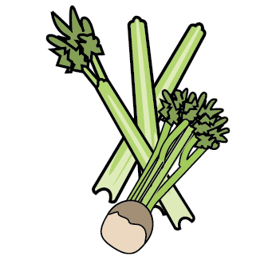 | 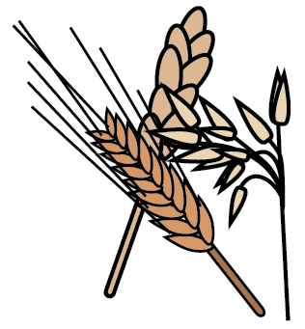 | 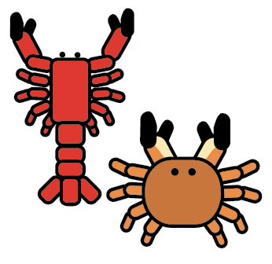 | 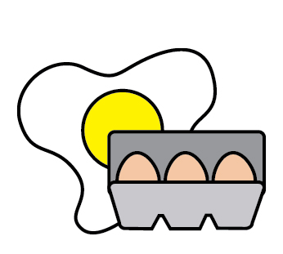 | 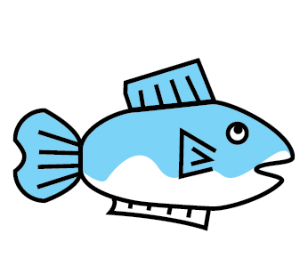 | 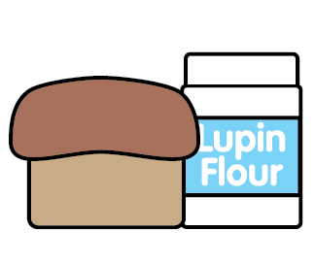 | 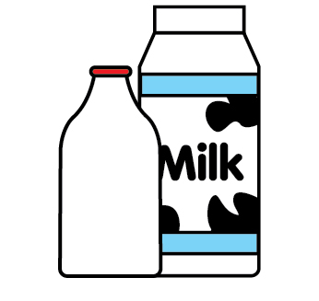 | 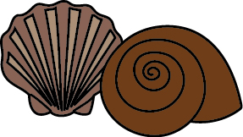 | 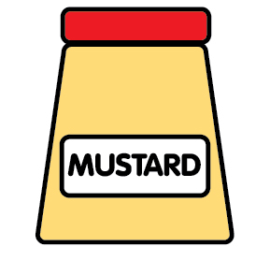 | 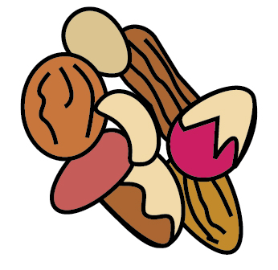 | 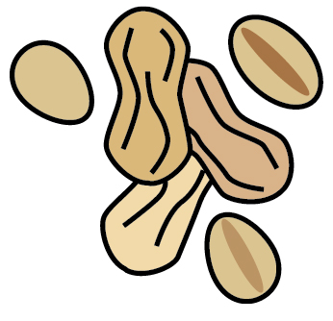 | 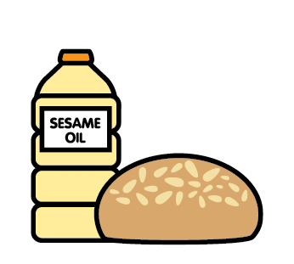 | 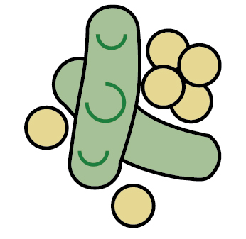 | 
 | Celery | Cereals containing gluten | Crustaceans | Eggs | Fish | Lupin | Milk | Mollusc | Mustard | Nuts | Peanuts | Sesame seeds | Soya | Sulphur Dioxide
Sausage roll |  | Wheat |  | ✓ |  |  | ✓
Vegan sausage roll |  | Wheat
Mince beef pie |  | Wheat
Jacket & beans
chicken
Veg, tomato, lentil stew
Chicken & bacon pasta |  | Wheat |  |  |  |  | ✓
Tomato & spinach pasta bake |  | Wheat |  |  |  |  | ✓
FISH FINGERS |  | WHEAT |  |  | ✓
QUORN FINGER |  | WHEAT

DISHES AND THEIR ALLERGEN CONTENT -MAIN COURSE PRIMARY WEEK 2

DISHES
 | Celery | Cereals containing gluten | Crustaceans | Eggs | Fish | Lupin | Milk | Mollusc | Mustard | Nuts | Peanuts | Sesame seeds | Soya | Sulphur Dioxide
Chilli con carne
Vegetable con carne
Bbq chicken thigh
Bbq quorn fillet |  | Wheat
Gammon
Veg tartlet |  | Wheat |  | ✓ |  |  | ✓ |  |  | May contain traces
Chicken & leek pie |  | Wheat |  |  |  |  | ✓
Homity pie |  |  |  |  |  |  | ✓
Chicken Nuggets | ✓ | Wheat |  |  |  |  | ✓ |  | ✓ |  |  |  | ✓
Quorn Nuggets |  | Wheat
Waffle |  | Wheat

DISHES AND THEIR ALLERGEN CONTENT -MAIN COURSE PRIMARY WEEK 3

DISHES
 | Celery | Cereals containing gluten | Crustaceans | Eggs | Fish | Lupin | Milk | Mollusc | Mustard | Nuts | Peanuts | Sesame seeds | Soya | Sulphur Dioxide
Chicken korma |  |  |  |  |  |  | ✓ |  |  | May contain | May contain
Sweet potato & lentil curry |  |  |  |  |  |  | ✓ |  |  | May contain | May contain
Hot dogs |  | wheat |  |  |  |  |  |  |  |  |  | May contain | ✓ | ✓
Vegetable sausage hotdog |  | Wheat |  |  |  |  |  |  |  |  |  | May contain
pork
Cheese & onion |  | Wheat |  | ✓ |  |  | ✓
Cowboy stew |  | Wheat |  |  |  |  |  |  |  |  |  |  | ✓ | ✓
Jacket & cheese |  |  |  |  |  |  | ✓
FISH CAKES |  | WHEAT |  |  | ✓
QUORN FINGERS |  | WHEAT

