DISHES AND THEIR ALLERGEN CONTENT WEEKS 1, 2, 3

Week 1 Dishes | 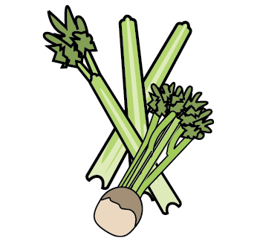 | 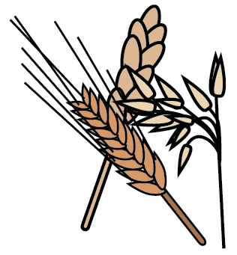 | 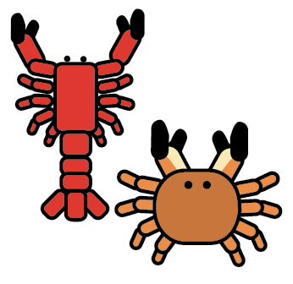 | 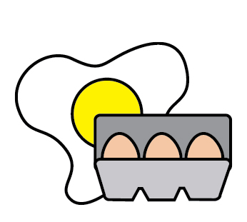 | 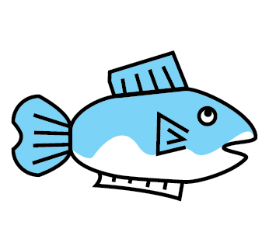 | 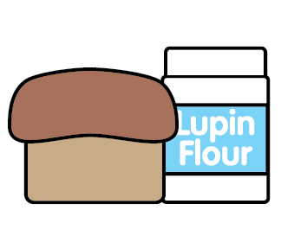 | 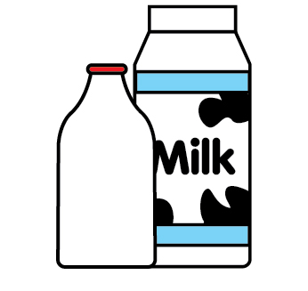 | 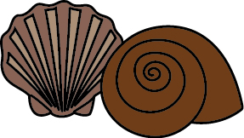 | 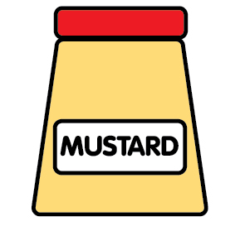 | 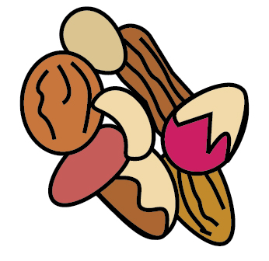 | 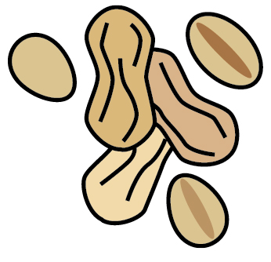 | 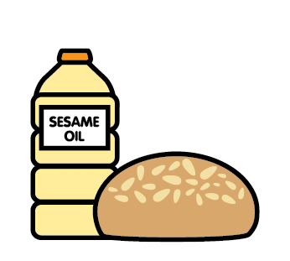 |  | 
 | Celery | Cereals containing gluten | Crustaceans | Eggs | Fish | Lupin | Milk | Mollusc | Mustard | Nuts | Peanuts | Sesame seeds | Soya | Sulphur Dioxide
KATSU CHICKEN  (COCONUT CREAM) | ✓ | WHEAT/ BARLEY |  |  |  |  | ✓ |  | ✓ |  |  |  | ✓
KATSU QUORN  (COCONUT CREAM) |  | WHEAT / BARLEY |  |  |  |  |  |  |  |  |  |  | ✓
JACKET POTATO
CHICKEN
FETA TART |  | WHEAT |  | ✓ |  |  | ✓ |  |  | TRACES
BOLOGNESE PASTABAKE |  | WHEAT |  |  |  |  | ✓
VEGETABLE PASTABAKE |  | WHEAT |  |  |  |  | ✓
FISH FINGERS |  | WHEAT |  |  | ✓
QUORN FINGER |  | WHEAT

Week 2 Dishes
 | Celery | Cereals containing gluten | Crustaceans | Eggs | Fish | Lupin | Milk | Mollusc | Mustard | Nuts | Peanuts | Sesame seeds | Soya | Sulphur Dioxide
CHICKEN SAUSAGE |  | WHEAT |  |  |  |  |  |  |  |  |  |  | ✓ | ✓
VEGAN SAUSAGE |  | WHEAT
CHICKEN AND CHORIZO RAGO | ✓
VEGETABLE RAGU | ✓
GAMMON
VEGETABLE TART |  | WHEAT |  | ✓ |  |  | ✓ |  |  | TRACES
HAM & LEEK PIE |  | WHEAT |  |  |  |  | ✓
QUORN & LEEK PIE |  | WHEAT |  | ✓ |  |  | ✓
CHICKEN NUGGETS | ✓ | WHEAT |  |  |  |  | ✓ |  | ✓ |  |  |  | ✓
QUORN NUGGETS |  | WHEAT

Week 3 Dishes
 | Celery | Cereals containing gluten | Crustaceans | Eggs | Fish | Lupin | Milk | Mollusc | Mustard | Nuts | Peanuts | Sesame seeds | Soya | Sulphur Dioxide
HUNTERS CHICKEN |  |  |  |  |  |  | ✓
HUNTERS QUORN |  | WHEAT |  |  |  |  | ✓
CHICKEN & VEGETBLE PIE |  | WHEAT
QUORN & VEG PIE |  | WHEAT |  | ✓
PORK
CHEESE & ONION PASTY |  | WHEAT |  |  |  |  | ✓
SHEPHERDS PIE
VEGETABLE HOT POT
FISH CAKES |  | WHEAT |  |  | ✓
QUORN FINGERS |  | WHEAT

