Weavers Cycle B Spring Termly Overview
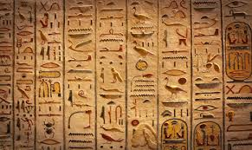
Ancient Egypt
Enrichment Opportunities | Tutankhamun Exhibition, Dorchester
Courageous Advocate/
Justice and Responsibility
History | Geography | RE
Who were the Ancient Egyptians? | Egypt and the Nile | Judaism – How important is it for Jewish people to do what God asks them to do?  Understanding Christianity: Gospel What kind of world did Jesus want?
English Texts |  | Just Read Books
Marcy and the Riddle of the Sphinx by Joe Todd-Staunton  The Story of Tutankhamun |  | Letters From the Lighthouse
Art and DT | Music and Spanish | Values
Painting  Fauvism artists (discovery, wonder and courage)  Printing and symmetry (Egyptian designs)  Making a light including an electrical component | PPA COVER | Respect  Perseverance
Science
T3: Electricity Y4
T4: Living things and their Habitats Y4
PE
Cognitive Dynamic Balance: On a Line Coordination: Ball Skills
Creative Coordination: Sending and Receiving Counter Balance: With a Partner
T3: Orienteering
T4: Swimming/ rugby or netball

