Sounds- Write
Enrol in the parents’ online training at:
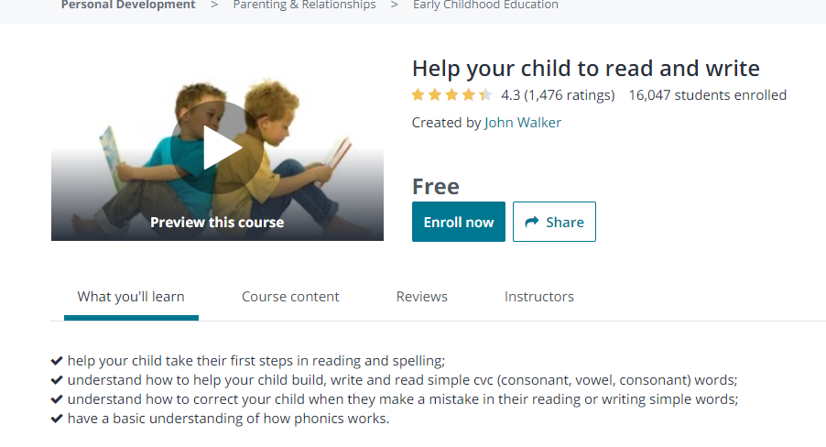
https://www.udemy.com/course/help-your-child-to-read-and-write/
Requirements
- You don't need any prior knowledge.
Description
This course introduces you to the Sounds-Write phonics program, and gives you the knowledge, resources and activities you need to help your child to start learning to read and write.
The course is designed for parents and carers of children aged 4 to 6 who want to know how to get their children started in their journey towards becoming literate.
If your child is using Sounds-Write at school, this course will teach you how to support them with their homework.
All the videos have captions to help you make the most of them. Please enable them if you need them.
Who this course is for:
The course is for parents or carers who want to give their children aged 4 to 6 a good start in learning to read and spell using a phonics program.
- As always, further questions, comments or queries to
woodley@crockerton.wilts.sch.uk

