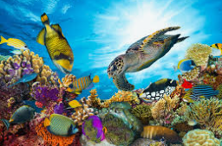
Autumn Term
2024 Cycle A Potters Class - EYFS
Where in the World?

Understanding the World  People, Culture and Communities  The Natural World |  | RE  Concept – Creation  Why is the word ‘God’ so important to Christians?
Describe their immediate environment using knowledge from observation, discussion, stories, non-fiction texts and maps.  Weekly welly walks observing local environment and understanding places in relation to each other. Map making of school and local environment around school.  • Know some similarities and differences between different religious and cultural communities in this country, drawing on their experiences and what has been read in class.  Explore the Creation Story. Explore child’s perception of God as Creator.  • Explain some similarities and differences between life in this country and life in other countries, drawing on knowledge from stories, non-fiction texts and – when appropriate – maps  Explore life in the seas and oceans, here and around the world.  Explore the natural world around them, making observations and drawing pictures of animals and plants.  Weekly walks observing the changing season, identifying found objects and describing what they see and find..  • Know some similarities and differences between the natural world around them and contrasting environments, drawing on their experiences and what has been read in class.  Make comparisons between the natural, rural environment and the town of Warminster.  • Understand some important processes and changes in the natural world around them, including the seasons and changing states of matter.  Observe, discuss and record changes of season. Develop vocabulary associated with natural environment and seasons. |  | Expressive Arts and Design  Creating with Materials  Being Imaginative and Expressive  Using a range of media and materials create paintings, collage and models of sea creatures, environments and natural objects.  Explore and use a variety of tools including scissors, brushes, holepunchers.  Sing songs from memory and explore a range of musical instruments. Listen and appreciate music linked to underwater theme, Handel’s Water Music, theme from Finding Nemo.  Submarine role play, create scenes and narratives using props and role play equipment.  Water and sand (beach) play.  Sing a range of well-known nursery rhymes and songs.  • Perform songs, rhymes, poems and stories with others, and – when appropriate – try to move in time with music.
English Texts:
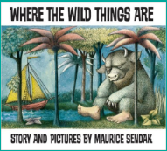
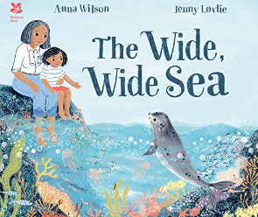
The Wide, Wide Sea
Commotion in the Ocean
Where the Wild Things Are
Snail on the Whale
Ocean full of wonder- poetry

 | Values – Friendship  Compassion  Year 6 Buddies  Circle time  Friendship stories  Role Play | Courageous Advocacy – Protecting the Oceans, disposing of plastic  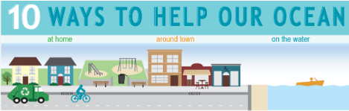
 | Class reader : My Naughty Little Sister

